Practical no. 3
Name :- Danish Altaf Solkar Enrolment no. :-24111590805
Class :- CO3K – B Subject :- DMS
Aim:- Execute DDL commands to manage database using SQL

QUERY :- CREATE TABLE Student(s_name VARCHAR(10),s_age NUMBER(3),s_roll NUMBER(2));
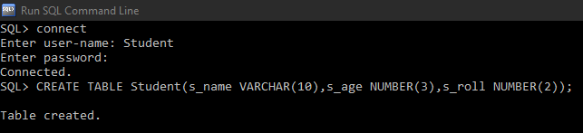

QUERY :- desc student;
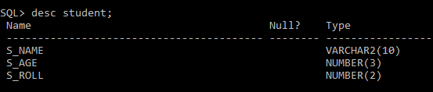

QUERY :- ALTER TABLE student RENAME TO stud;
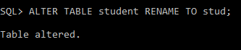

QUERY :- ALTER TABLE stud RENAME COLUMN s_roll TO s_rollno;
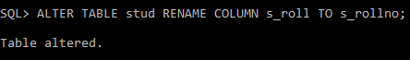

QUERY :- desc stud;
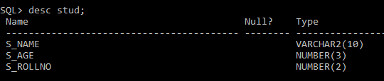

QUERY :- CREATE TABLE arkp(sr_no NUMBER(2),name VARCHAR(10),address VARCHAR(10));
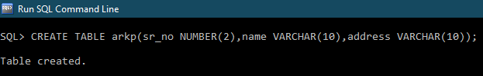

QUERY :- INSERT INTO arkp VALUES(1,'Danish','Karjat');
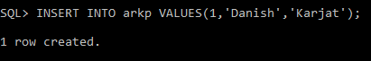

QUERY :- SELECT * FROM arkp;
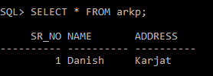

QUERY :- TRUNCATE TABLE arkp;
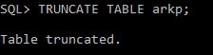
QUERY :- SELECT * FROM arkp;
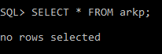

QUERY :- SELECT table_name FROM user_tables; 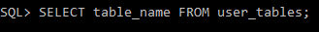
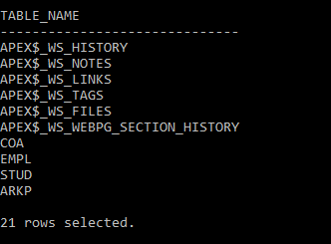
QUERY :- DROP TABLE arkp;
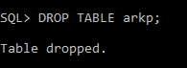

QUERY :- SELECT table_name FROM user_tables;
